**Tutorial of the use of my program**

**How can you use my program to sort a tcpdump file and analyze the results that interest us?**

**First, upload your tcpdump file and give it a name. For my part, its name is “Fichier_a_traiter.txt”. Then, place it in an easily accessible place such as the desk for example.**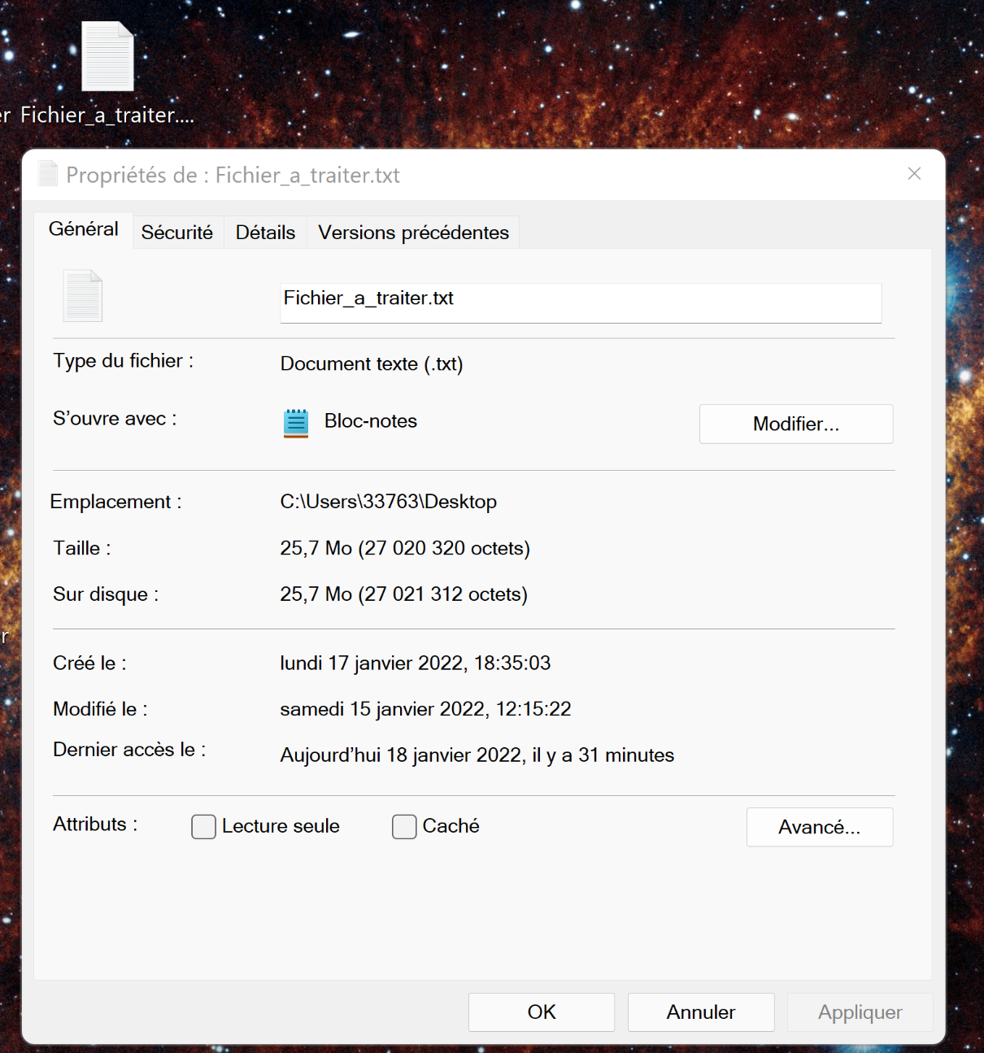

**For me the location is « C:\Users\33763\Desktop ».**

**Then open the sae15.py program with software such as Spyder to make sure the program works with the modules I used.**

**Go to line 5 of the file and specify the path you copied previously, while not forgetting to add “/nameofyourfile” at the end of the location. Second step: replace all the "\" in your path with "/" because python does not understand the "\" of Windows.**

**In my case it gives that:**



**Then go to line 302, you will put the path you want here, the program will create an html page at the place you specify, I advise you to do it in the same place as the one mentioned above : on the desktop.**

**For me the path is this:**



**My file will be named “page.html” (html being the extension, you should not touch it) however you can name your file as you wish, it can for example be named “mypage.html”**

**Then go to line 460, here you will put the path for the automatic creation of the first csv file usable by excel which will contain the sorted data of the tcpdump file.**

**Again, in order not to get lostI advise you to put it on the desk.**

**This is the path for me :**



**Which is « C:/Users/33763/Desktop/donnees.csv ».**

**Here you can change the name of the file again (therefore replace “donnees” with something else) but do not touch the extension (.csv) otherwise the file will not be the one expected.**

**Then go to line 467, you will do the same thing as before but to create a second csv file usable by excel which will be statistics concerning the tcpdump file.**

**Here is the link for me:**



**You can change the "statistiques" which corresponds to the name of the file but do not touch the extension, as before.**

**If you put the same link each time (the link that points to your desktop) you are sure not to get lost and then find all your files created by the python program.**

**Then go to line 174 and 184, here you have 2 paths to modify. I advise you to put the same path that points to your desktop.**

**If you want you can change the names of the 2 graphs by replacing "graphique" and "graphique2" by the name of your choice.**

**(These are the link to modify):**





**2 last steps:**

**Go to lines 206 and 231, you will copy the paths entered lines 174 and 184 to line 206 and 231 respectively.**

**My paths are as follows:**





**Once these steps are completed, you can launch the program. If it doesn't work, make sure you have changed the "\" to "/" and that you have the right path. To check the correct path, just right click on a file on the desktop, for example, to see the file path (its location), as explained at the beginning.**

**The files should appear on your desktop if you took the same paths than me.**

**Then open the first csv file with excel.**

**This should appear :**

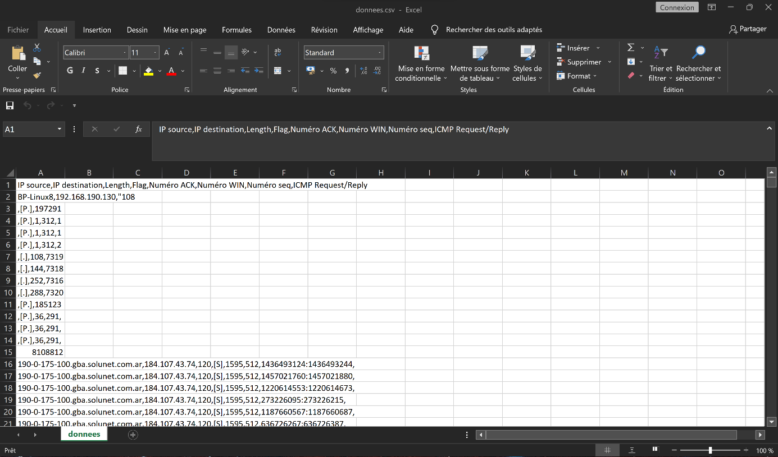

**Then click on data (here in french it’s données).**



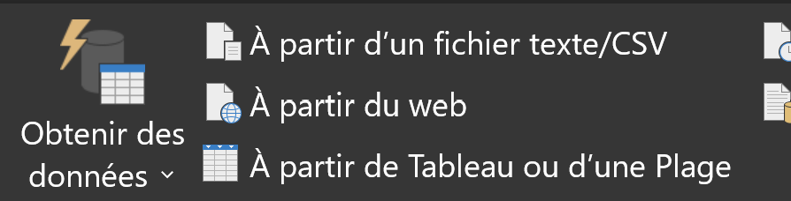

**Then click to "From text/CSV file" (in french it’s “A partir d’un fichier texte/CSV”)**

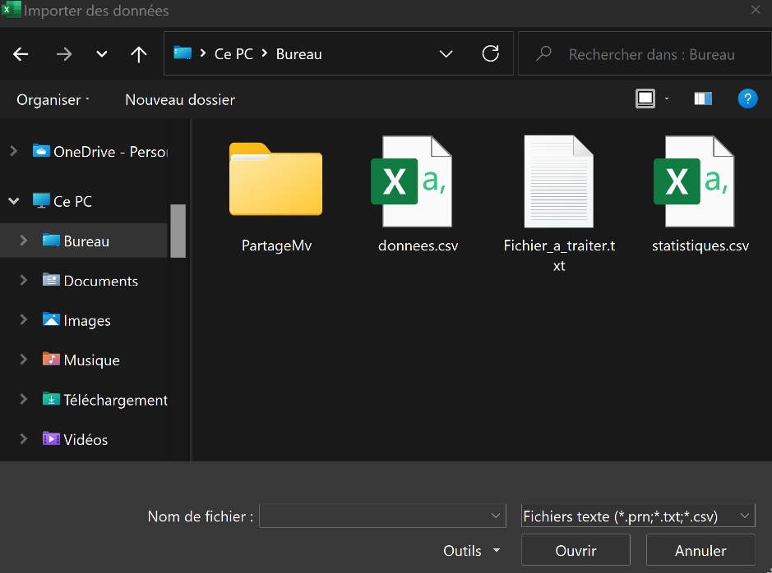

**Then select the file you just launched, so mine was donnees.csv.**

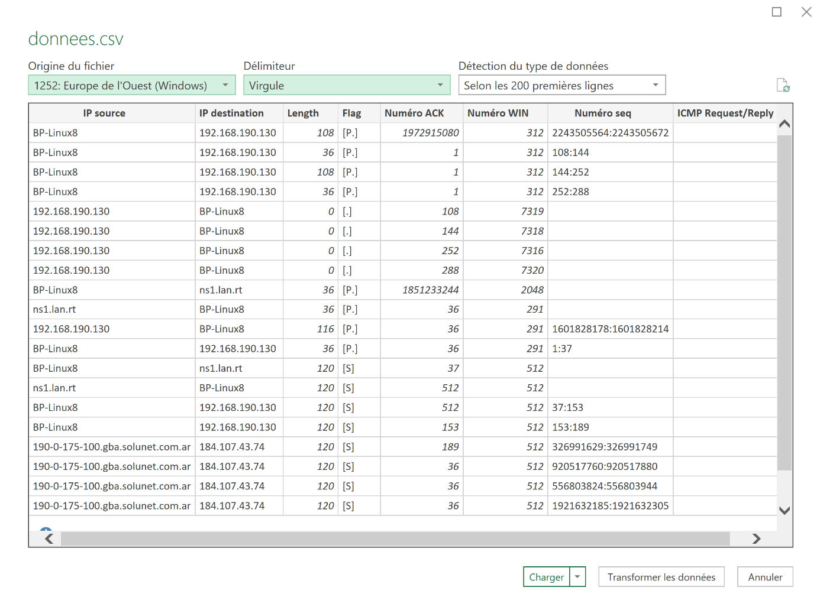

**Then select as delimiter the comma and finally press the loader.**

**Here is the first page containing the useful informations of the sorted tcpdump.**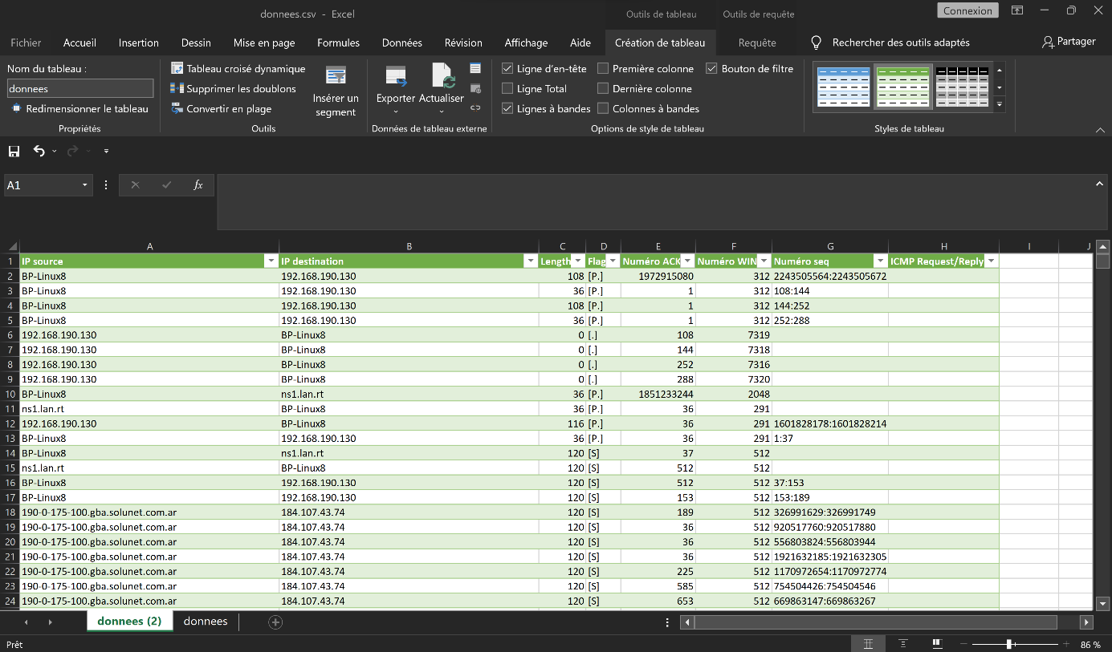

**Do the same for the second file, so you have to : launch it, click on "Data", then "From a CSV file", select the second the csv file you have just opened, then put the comma as a delimiter and finally "Load".**

**You should see these stats appear here:**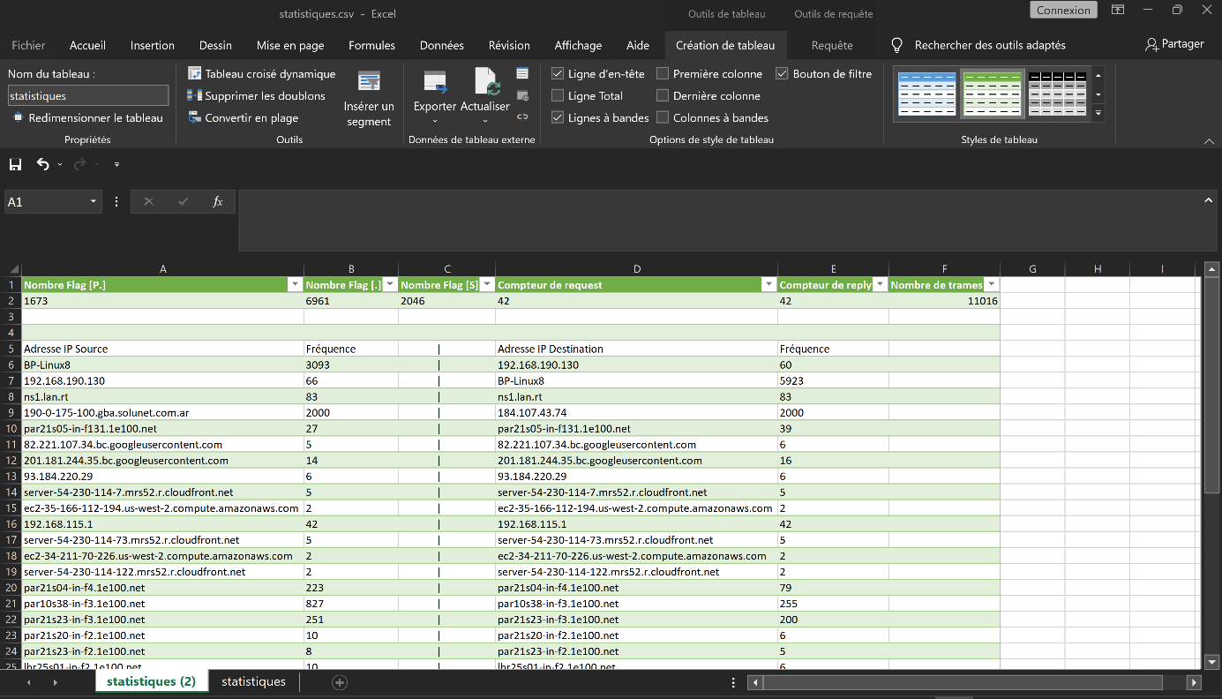

**You can now launch your html page, go to where you specified the path, if you did like me it will be on your Desktop, and you just have to double click on it and select your favourite browser if the page doesn’t start automatically.**

**Here's what you should have:**